OkDCN/GWEP Age Friendly Nursing Home ECHO Special Session
Emergency Response with Dementia Adults
Wednesday,
10:30am – 12:00pm
Presenter
Kieulia Blackmon, MAHS, MPH, CHES
CEO
Heart 4 Life BLS and First Aid

ANCC Accreditation Statement: OU Medicine, Inc. is accredited with distinction as a provider of nursing continuing professional development by the American Nurses Credentialing Center’s Commission on Accreditation.
1.50 CNE contact hours will be awarded for meeting the following criteria: 90% attendance of conference, completion and submission of evaluation form.
This educational activity does not include any content that relates to the products and/or services of a commercial interest that would create a conflict of interest.
Social Work CEU Statement: OU Medicine, Inc., Case Management Department is accredited as a provider of social work CEUs by the Oklahoma State Board of Licensed Social Workers. This Educational Activity has been approved for 1.50 hours CEUs. Provider # 20260370 Category 1.

Receiving Continuing Education credit
NOTE: Continuing education credits are processed through the College of Medicine Office of Continuing Professional Development’s learning management system, CloudCME. You must have a CloudCME account in order to receive credits. If you do not have one, please see below for instructions.

1. To Record Attendance
You may record your attendance beginning 30 minutes prior to the beginning of the activity and up to 45-minutes after the conclusion of the activity.
To record your attendance, text the activity code to (405) 562-5828. You will receive the activity code at the session.

2. To Complete the Evaluation
The evaluation will be available on your CloudCME account. To access your account:
- Log in at cme.ouhsc.edu
- Click on My CME
- Click on Evaluations and Certificates. Once you have completed the evaluation, your certificate will be available. Credits will also show under Transcripts.

If you have an OUHSC email address, please read the information in the red boxes.
Creating a CloudCME Account

Step 1: Go to https://ouhsc.cloud-cme.com. Click Sign In.
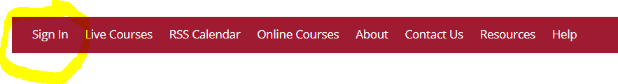

OUHSC Employees:
If you have an OUHSC e-mail address, you may already have a CloudCME account:
Click on Use this option if you have an OUHSC e-mail address
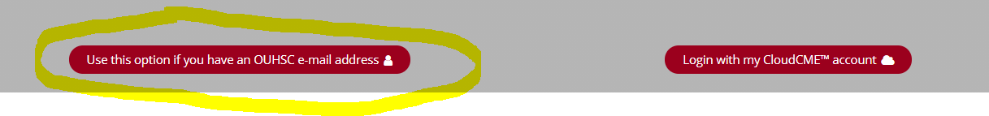

Enter your OUHSC user name and password
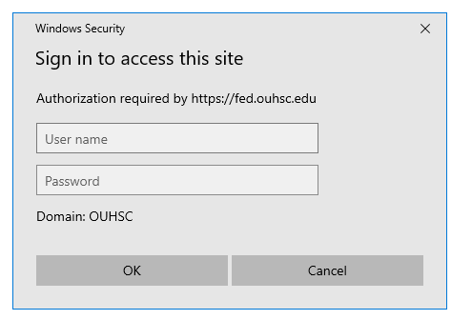

If your account is not found, proceed to Step 2 below
Step 2: Click Login with my CloudCME account
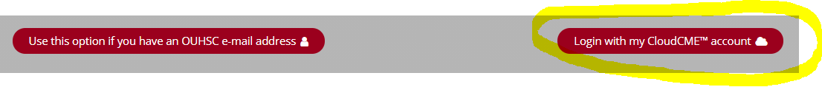
Step 3: Click the Create New Account button.

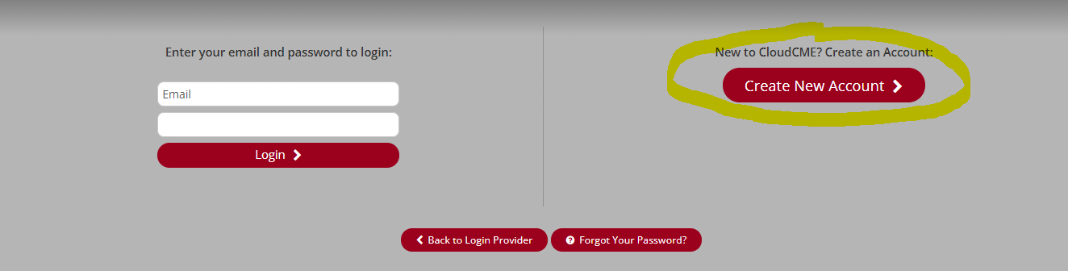
Step 4: Enter your information and check the User Agreement checkbox at the bottom. All fields are required. Click the Create Account button.

OUHSC EMPLOYEES: If you have an OUHSC email address, please enter your OUHSC password.

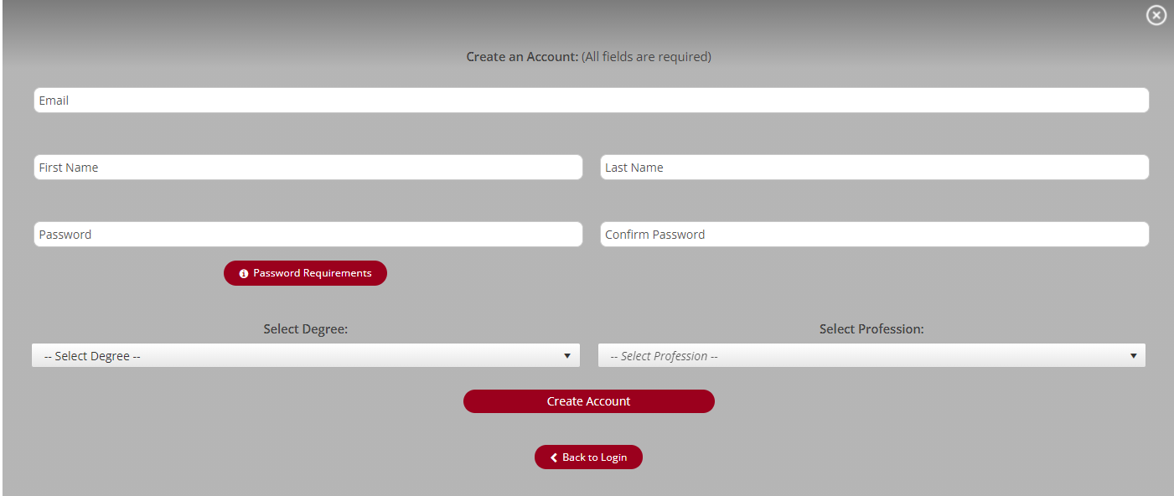

OUHSC EMPLOYEES: When you log into CloudCME, you will select the option, Use this option if you have an OUHSC e-mail address and will enter your OUHSC user name and password.
Once you have created your account, log in and update your profile:
1. Go to https://ouhsc.cloud-cme.com. Click Sign In
If you have an OU.edu email address: Click on Use this option is you have an OU.edu e-mail address and enter your OU email address and password.
If you do NOT have an OU.edu email address: Click on Login with my CloudCME account and enter your email address and password.
2. Click on My CME
3. Click on Profile
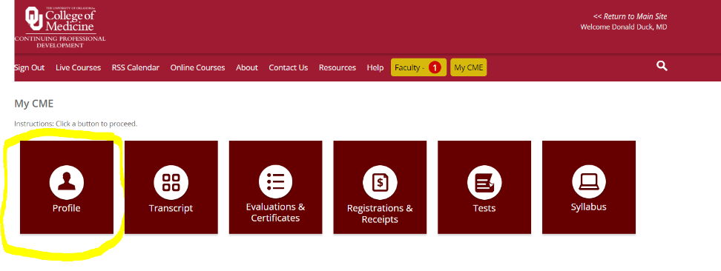

Any fields that are highlighted in red must be completed.
